Selection and Repetition Project
In this assignment, you will complete a program that uses a math trick to reveal a message.

Part I: Coding
- Create a new project called 03.10 Selection and Repetition Project in the Mod03 folder.
- Download the MathTrick.java file to the newly created folder.
- Complete the instructions and the static methods in the starter code.
- Utilize Math.random() and any other methods from the Math class as needed.
- Utilize the substring() method where appropriate.
- Each method should return a value of the correct data type.
- Call the completed static methods in the main method to complete a program that does the following:
  - Generate a random 3-digit number so that the first and third digits differ by more than one.
  - Reverse the digits to form a second number.
  - Subtract the smaller number from the larger one.
  - Reverse the digits in the answer you got in step c and add it to the number from step c.
  - Multiply by one million.
  - Subtract 733,361,573.
    - Important: Since the replaceLtr() method is expecting a String argument, you should use String.valueOf(number) method to create a String variable from the integer variable before the next step.
  - Using only the methods and concepts you have learned in this course so far, replace each of the digits in your answer with the letter it corresponds to using the following table:
0 → Y
1 → M
2 → P
3 → L
4 → R
5 → O
6 → F
7 → A
8 → I
9 → B
  - Using only the methods and concepts you have learned in this course so far, reverse the letters in the string to read your message backward.

Expected Output
The output of the program should resemble the following screenshot.

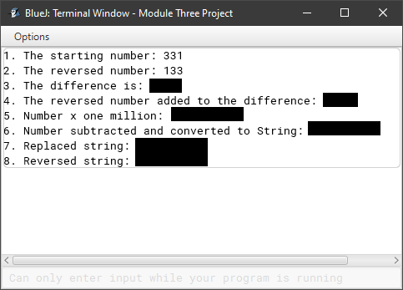

Part II: PMR
Using a word processing or text editing program of your choice, complete a PMR with the following reflections:
  - What went well with your program.
  - What you struggled with in your program.
  - What you would do differently in the future.

Part III: What to Submit
Submit the following to your instructor:
- The .java file for your program
- A .txt file (text file) with your program code
  - Copy your program code from BlueJ and paste it into a text file like Notepad or Notes.
  - Save your file using the same name as your program.
- A document with your PMR

